**Experiment 8**

**Student Name:** Sahil Kaundal **UID:** 21BCS8197

**Branch:** BE CSE (Lateral Entry) **Section/Group:** 807/B

**Semester:** 4th **Date of Performance:** 19/04/2022

**Subject Name:** MPI Lab **Subject Code:** 22E-20CSP-253

1. **Aim/Overview of the practical:**

Masking of 8-bit number.

**2. Task to be done/ Which logistics used:**

a) Mask the lower nibble of 8-bit number

b) Mask the higher nibble of 8-bit number

**3. Apparatus / Simulator Used:**

1. Jubin Application

2. 8085 Simulator

3. JDK

**4. Algorithms/Flowcharts:**

a) Mask the lower nibble of the 8-bit number

1. Load the content of memory location C050

2. Perform And operation of A with OF and store the result in memory location C051

3. Halt

b) Mask the Higher nibble of the 8-bit number

1. Load the content of memory location 3050

2. Perform OR With F0 and store in memory location 3051

3. Halt

**5. Programs:**

* Mask the lower nibble of 8-bit number

# BEGIN 0000H

LDA C050

ANI 0F

STA C051

HLT

# ORG C050

# DB 96H

* Mask the higher nibble of 8-bit number

LDA 3050

ORI F0

STA 3051

HLT

#BEGIN 3050

#DB 53H

**6. Result/Output/Writing Summary:**

* Mask the lower nibble of 8-bit number

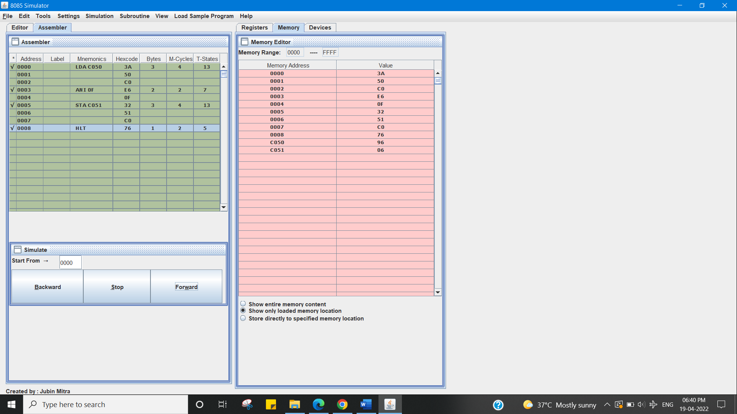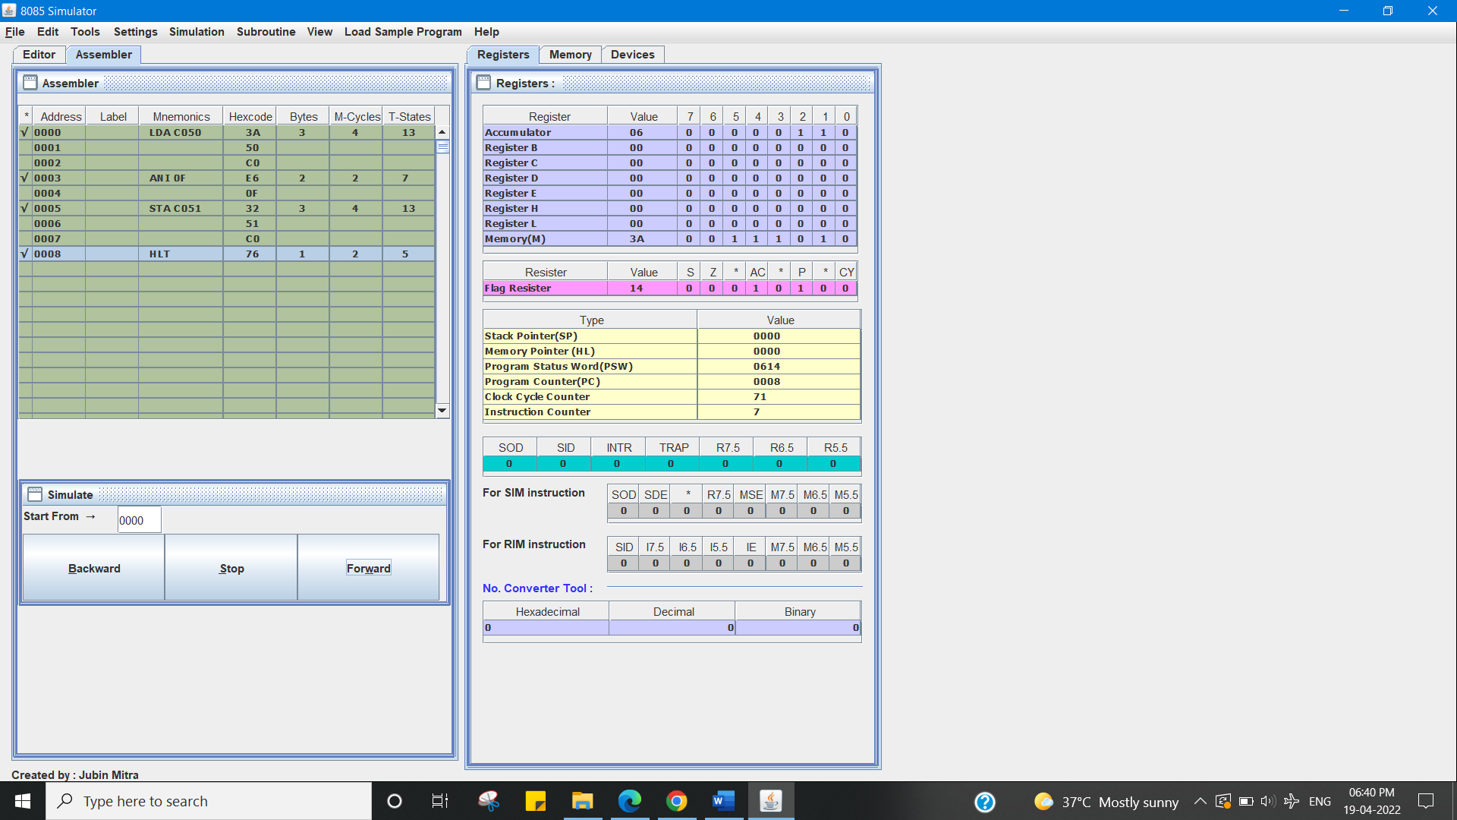

* Mask the higher nibble of 8-bit number

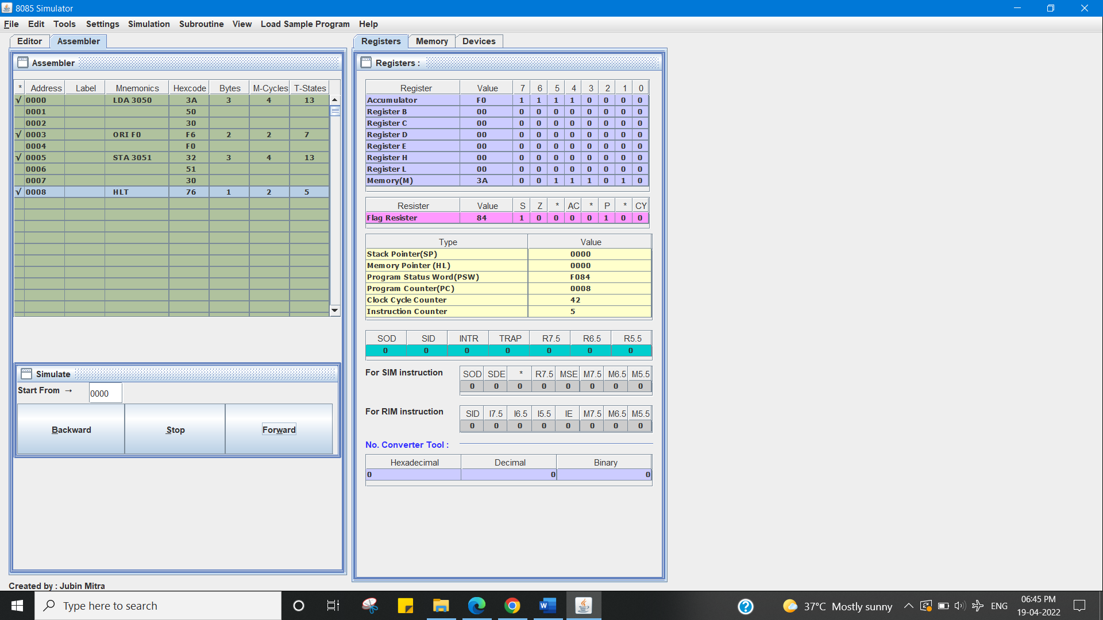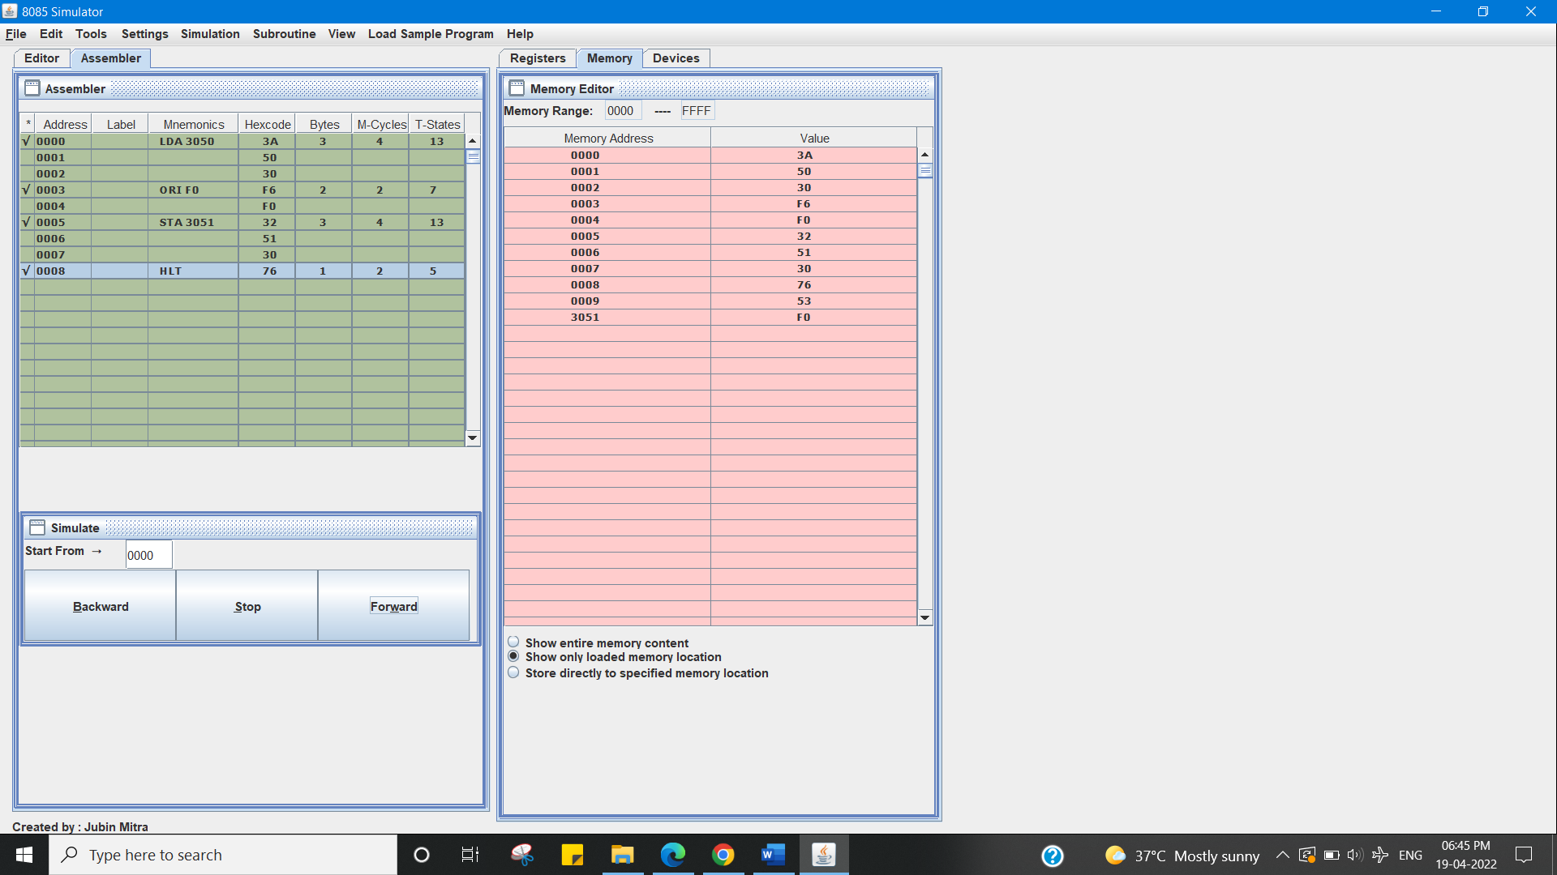

**Learning outcomes (What I have learnt):**

1. Working of microprocessors.

2. Learn how to Mask

3. Learn about 8085 simulator.

4. Operations of 8-bit numbers.

5. Learn about the different instructions that are needed to be given to the memory to perform Masking tasks.

**Evaluation Grid (To be created as per the SOP and Assessment guidelines by the faculty):**

|  |  |  |  |
| --- | --- | --- | --- |
| Sr. No. | Parameters | Marks Obtained | Maximum Marks |
| 1. |  |  |  |
| 2. |  |  |  |
| 3. |  |  |  |
|  |  |  |  |